Process to Setup MAC Laptop

1. Go to MY IT portal to raise order for “Light Managed device”

<https://myit.telekom.de/MyIT>

Select >> Order for myself.

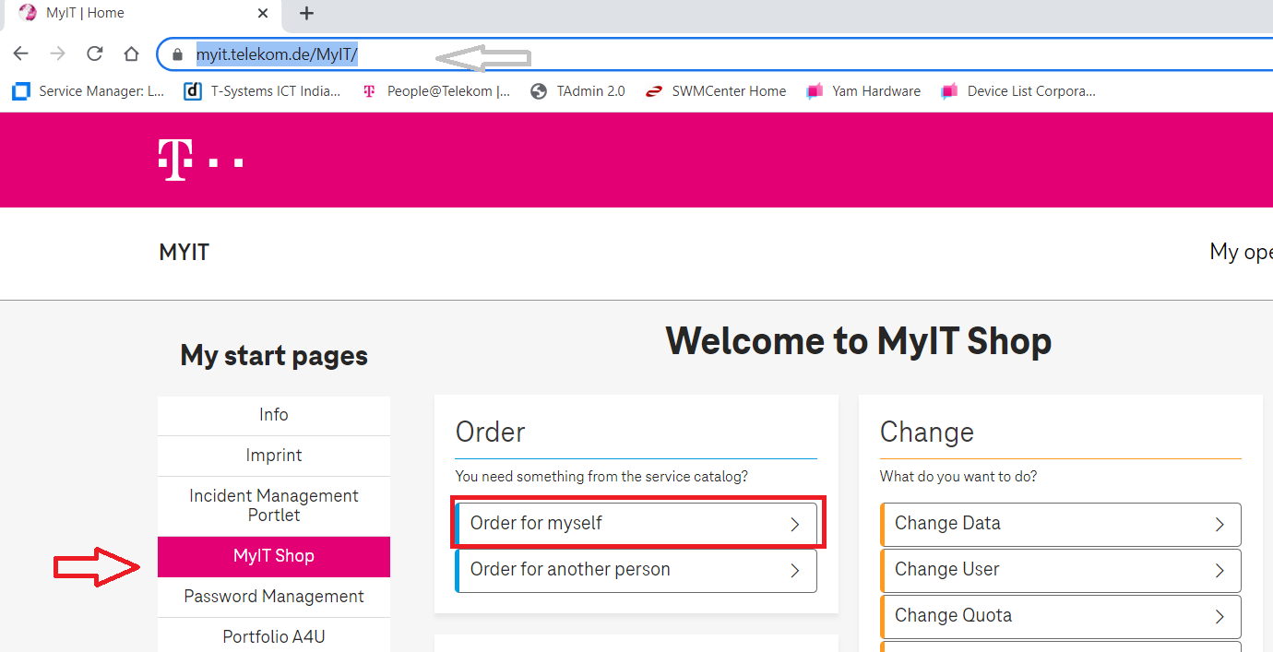

1. Please confirm your name, cost center and then select Continue.

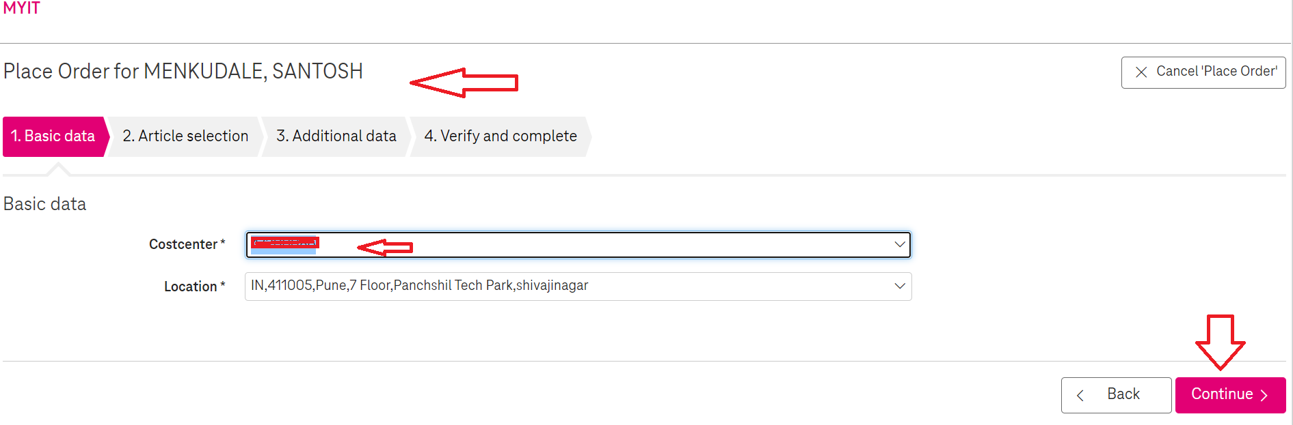

1. In the Search articles type “Light Managed Device” and press Search article

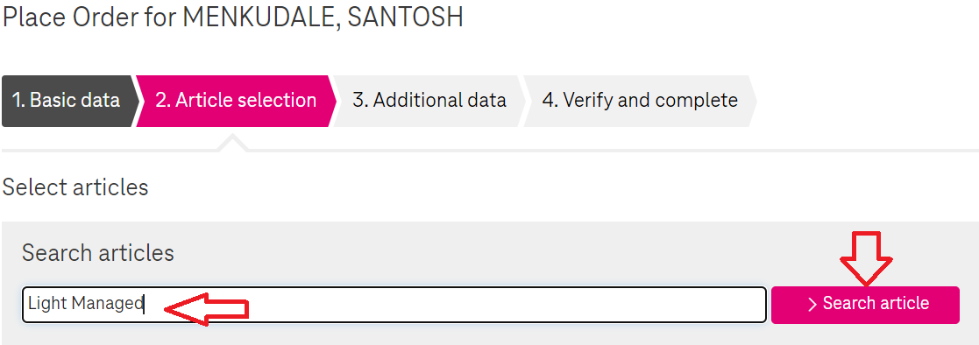

1. Once you got the “Light-Managed Device service” Select “ Select article” and continue.

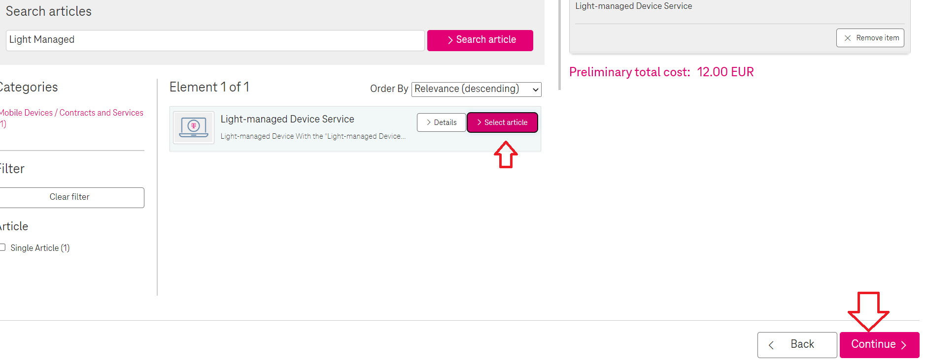

1. Provide your MAC laptop serial number and reason to use MAC laptop and select Continue.

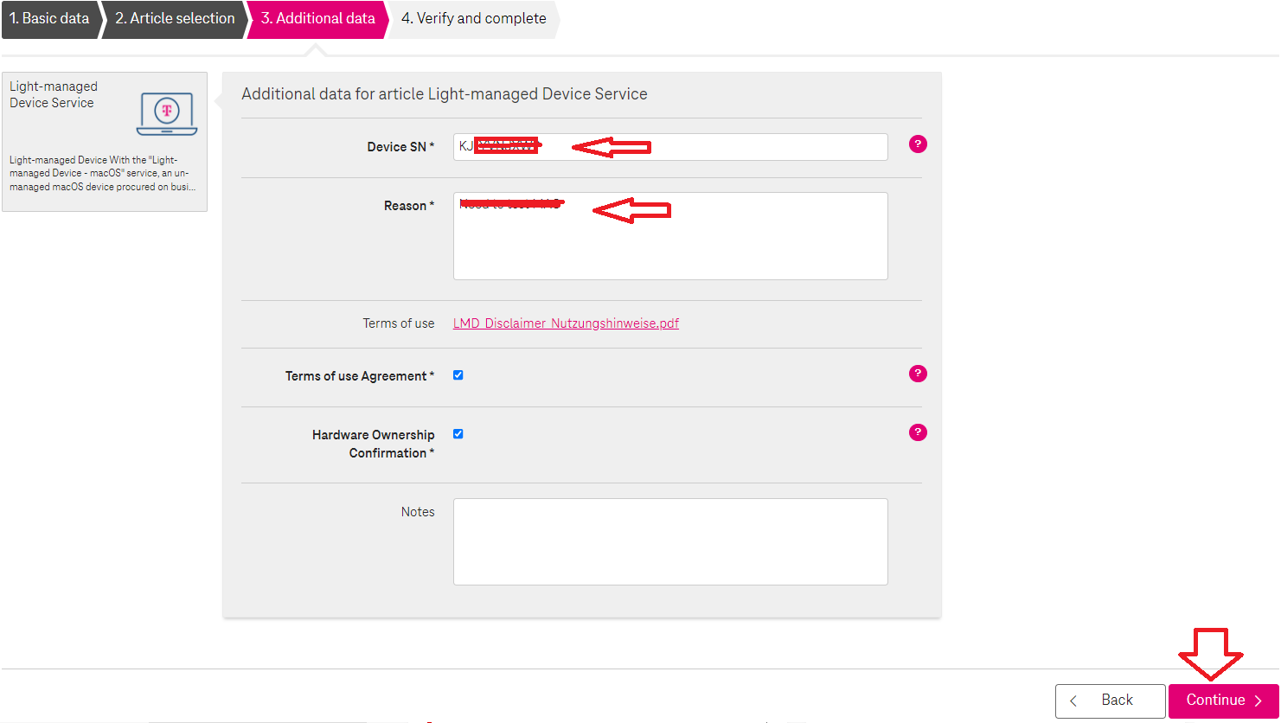

1. Verify the MAC laptop and other details and select “order now”.

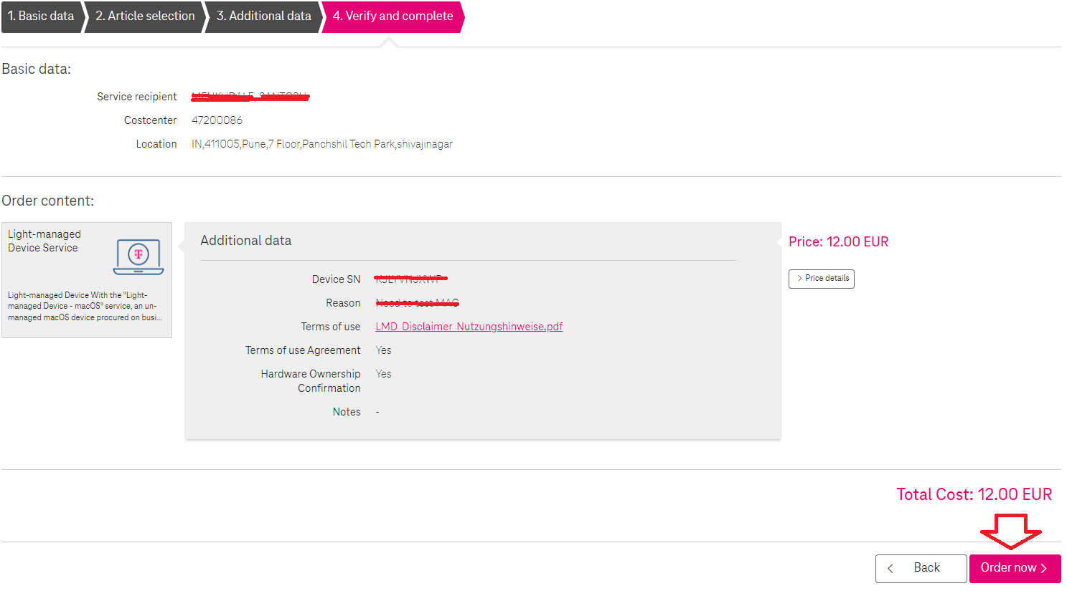

1. You will get an Approved email in next 2 hour, please see below.

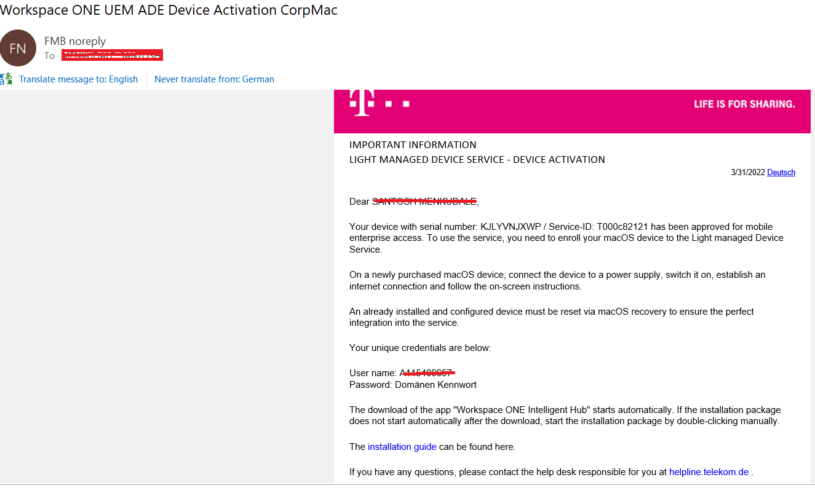

1. Once you have above mentioned email, hold power button of your MAC 20-30 seconds till you get the below screen.

Note:- Make sure that you have connected power chord.

Once you have below screen, select “Options”

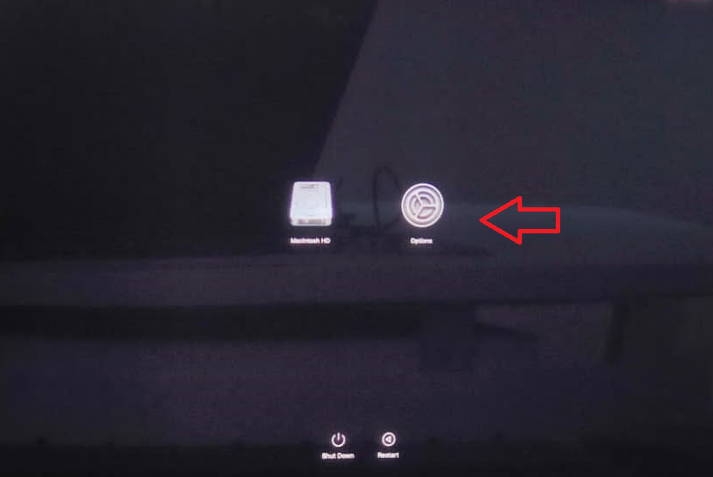

1. Select “Disk Utility”

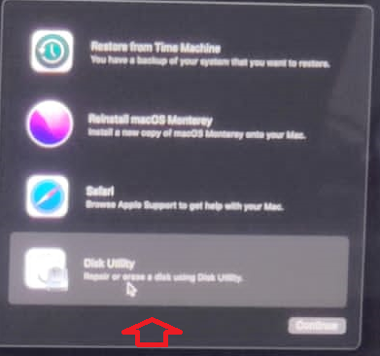

1. Select “Macintosh HD”

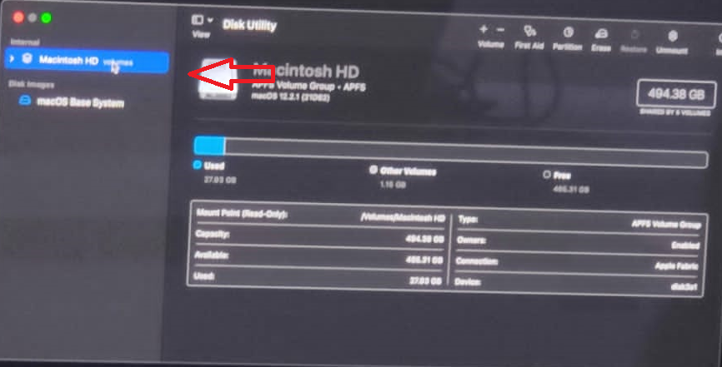

1. Select “Erase”

Note:- Make sure that, you have backed up or copied your data other device/location. Once the disk is erased you will not get any data from the disk.

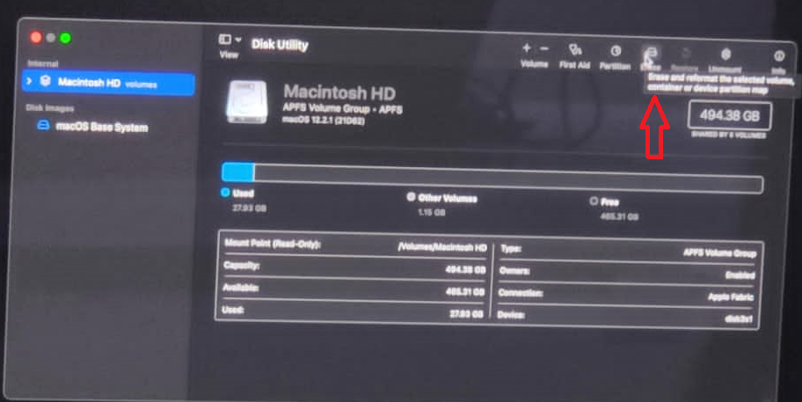

1. Select “Erase”

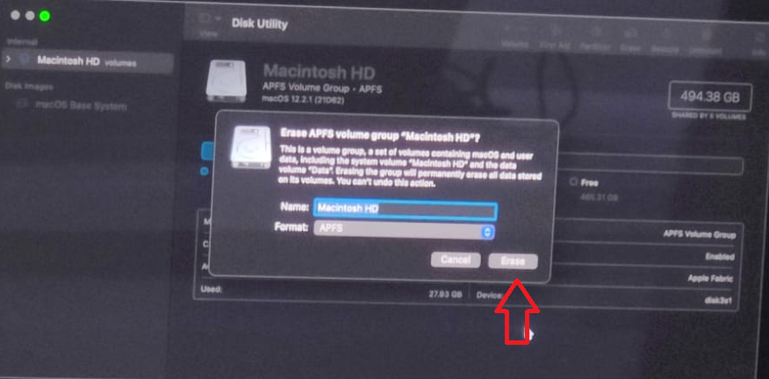

1. Select “Erase MAC” once its erased, it will ask for reboot the device. Please reboot the same.

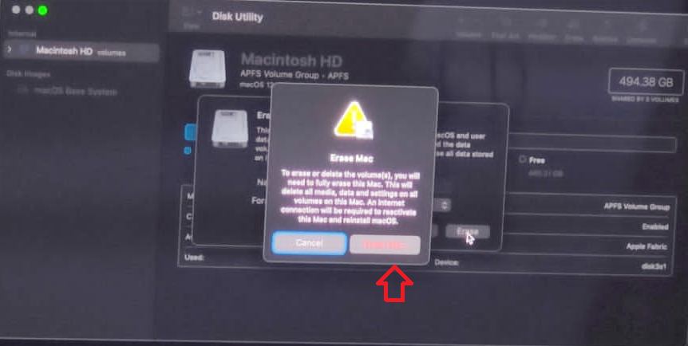

1. After reboot the device, this will ask for to connect your Wi-Fi network. Then connect your available network.

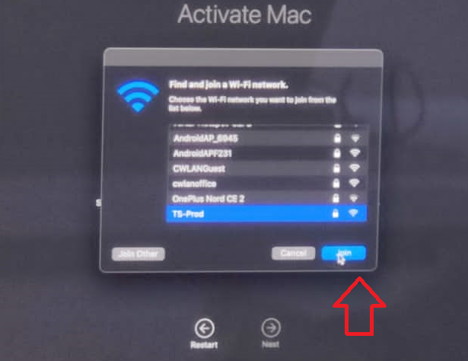

1. After join the Wi-fi network, this will start to process to activate your MAC device over the internet.

Once its activated, then select “Exit to Recovery”

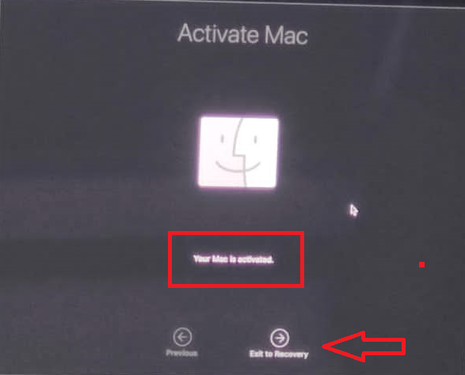

1. Once you are at Recovery option, select “Reinstall macOS”

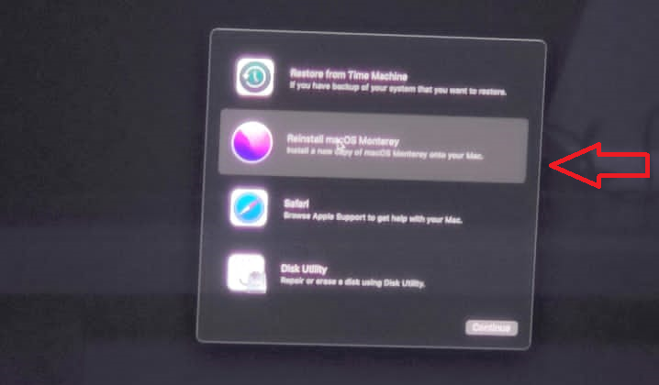

1. Select “Continue”

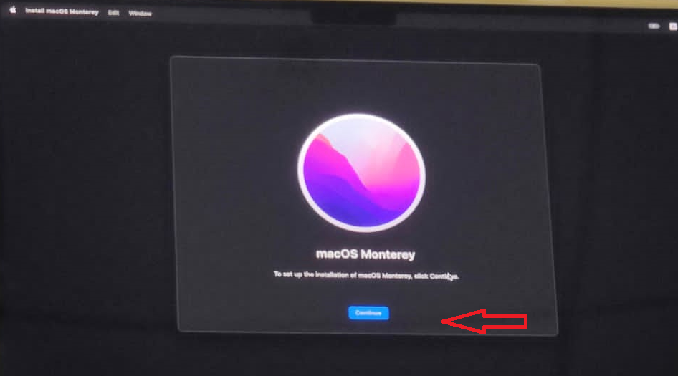

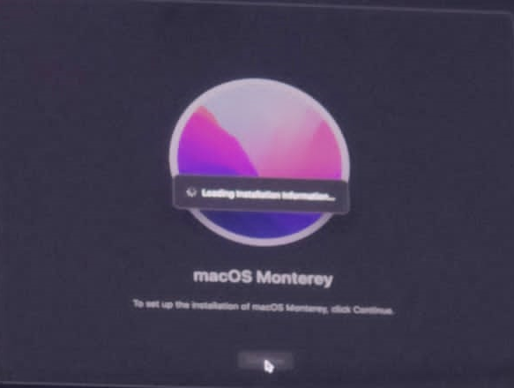

1. Select “Agree”

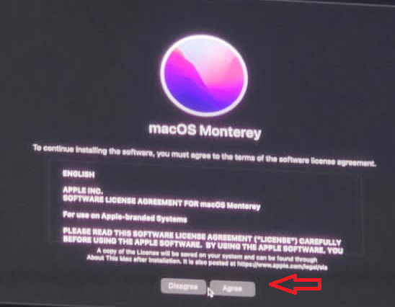

1. Select “Disk” and “continue”

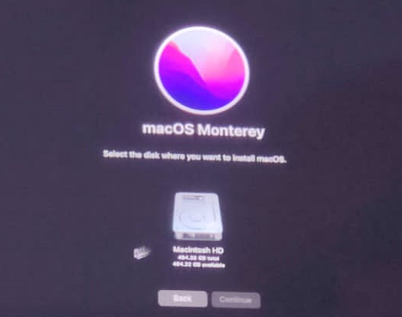

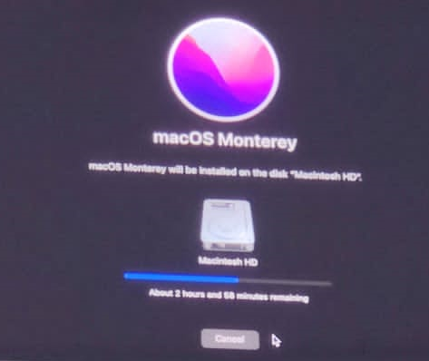

1. After completing the above mentioned process, reboot your laptop and your will get below screen and after that “Terms and Conditions” page, Scroll down all the page and accept the same.

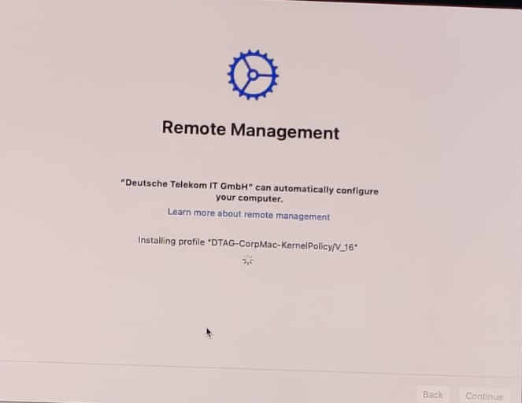

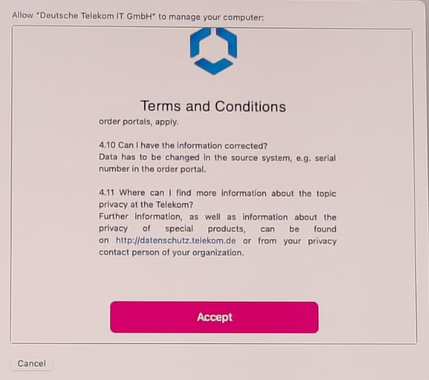

1. Here you will have to provide your “A ID” and Domain password and select “Continue”

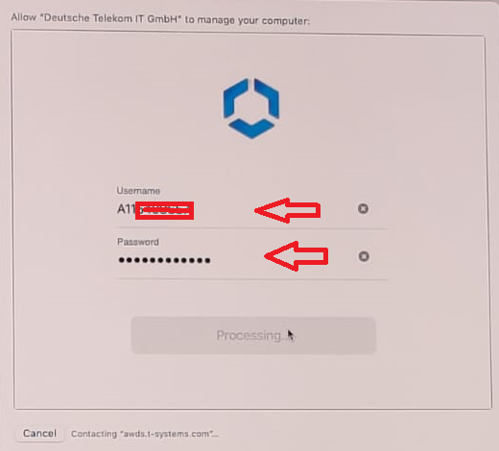

1. Select “Continue”

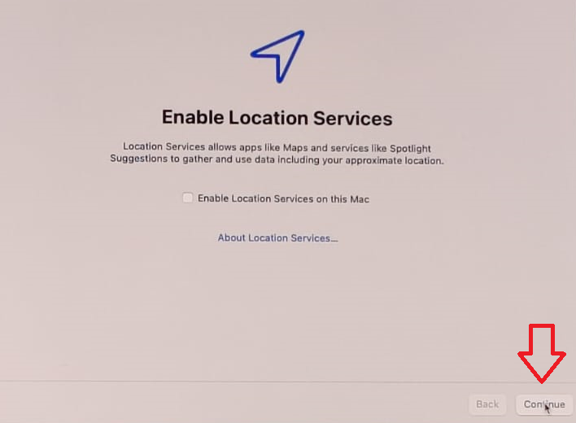

1. Select your “Time Zone” and “Continue”

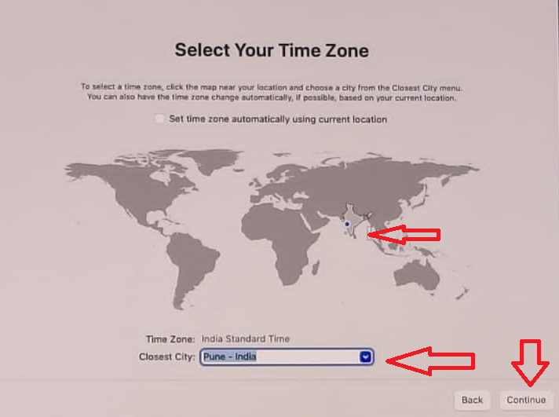

1. Provide password and select “Continue”

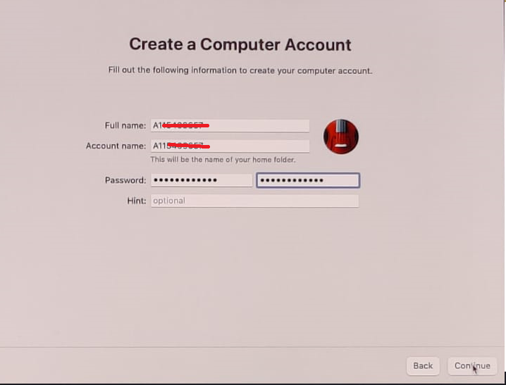

1. Once you logged in your MAC laptop, you will get below screen to update profile and policies. This will take approx. 30 -40 min to complete this setup.

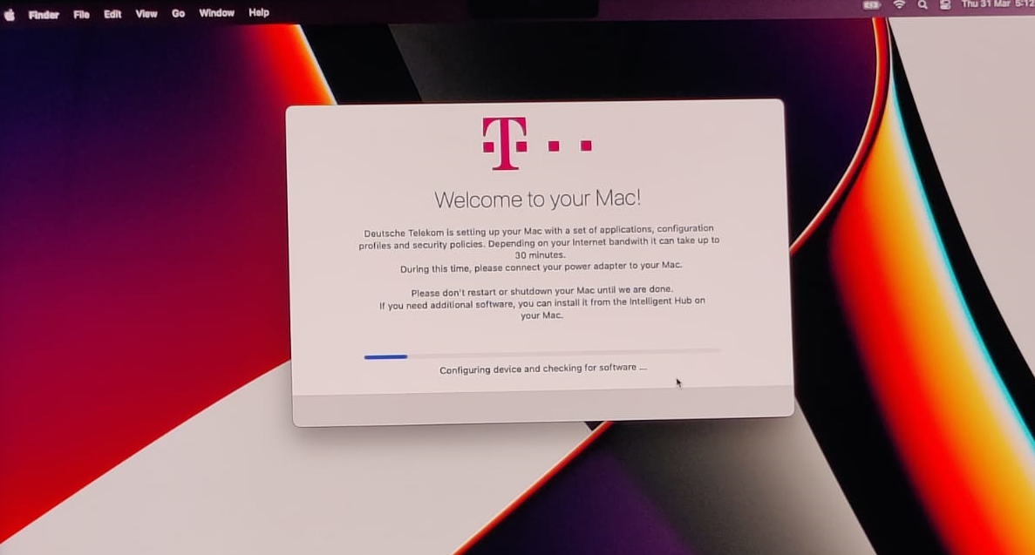

1. Once this is complete, please reboot your laptop and download the required applications from Intelligent Hub.